Children Affected by Divorce
Name
Institution Affiliation
Date

Children affected by divorce
Having children is one of the desires of couples, whether legally married or cohabiting. In the U.S one is allowed to marry one partner at a time, a set up called monogamy. The law however, does not bar anyone from having more than one partner at a time in their lifetime. At times, it is impossible to continue staying together in marriage due to various factors. Research has concluded that the level of divorce is on the rise. Those who are greatly affected by divorce are children. They experience mental and psychological effects which have ability to alter their lives completely. Children who experience divorce start performing poor in class, experience stress and anxiety and become mentally disoriented (Morin, 2018).
The U.S allows monogamy as the legal form of marriage. This is where one partner is allowed to marry just one partner at a time. This means that one can marry multiple partners at each time in their lifetime a situation referred to as serial monogamy. Being married to more than one spouse is a crime known as bigamy. There have been a marital decline as personal happiness is more regarded than marital commitment. The most affected group in divorce are the children.
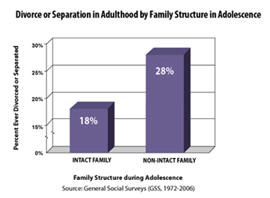
This chart shows that 28% of family of adolescents are divorced or not intact.
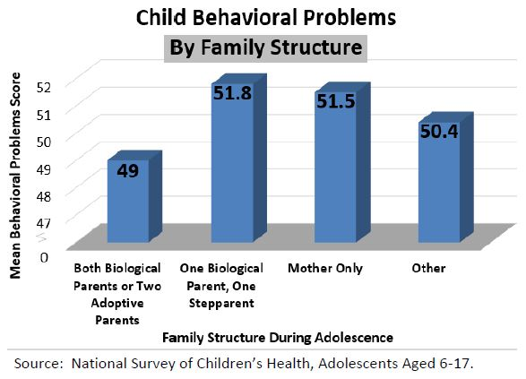
This chart shows that behavior problems are more in adolescents who are from one biological parent and a step parent, followed by those in families with mothers only. This shows a positive relationship between divorce and behavioral problems of children.
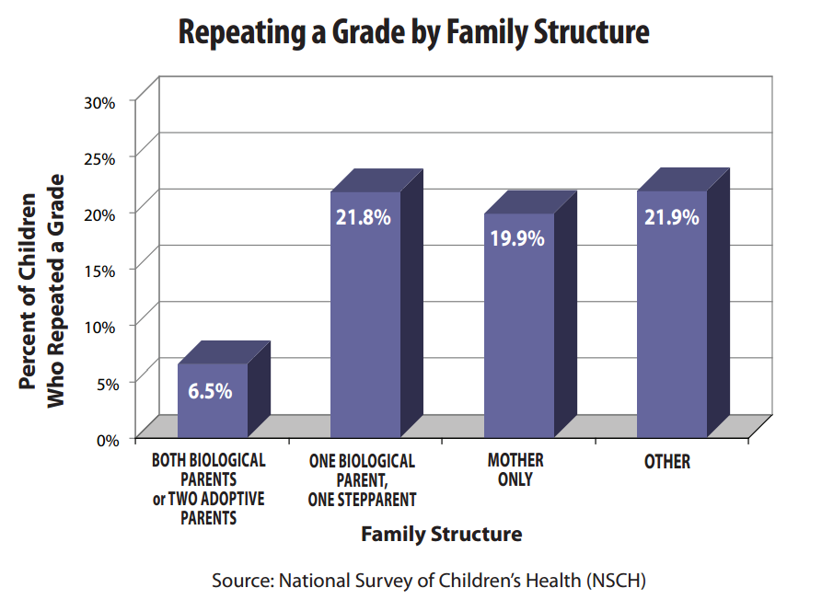
This chart shows that more children from divorced families repeat a grade. This is consistent with the finding that those divorced children experience a dip in their academic performance.
A social problem is an issue that affects considerable number of individuals in a society. Divorce qualifies to be a social problem because it have widespread effects on children and also the divorced spouses. Research has found that divorced spouses experience decline in income and health. Women particularly, experience reduction in income after divorce in a large scale than men. Men on the other hand experience deterioration of health after divorce more than women. Children experience social, psychological and emotional problems as a result of divorce.

References

Morin, A. (2018, August 24). The pschological effect of divorce on children. Retrieved from verywell family: https://www.verywellfamily.com/psychological-effects-of-divorce-on-kids-4140170

